How to create a report of all loans which are overdue by 30 or more days | 
Yoel Kortick
Senior Librarian

ONE
From Alma do menu “General > Analytics > Design Analytics”

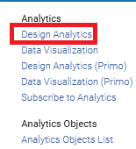

TWO
From Analytics do “New > Analysis” and choose subject area “Fulfillment”

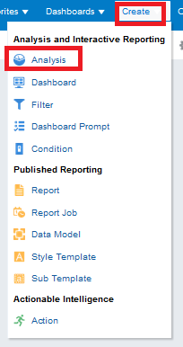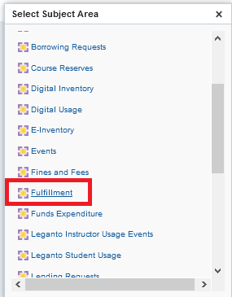

THREE
From left pane drag desired fields to right pane
For example drag these fields to the right pane:

- Due Date > Due Date
- Item Location at time of loan > Library Name
- Item Location at time of loan > Location name
- Bibliographic Details > Title
- Loan Details > Barcode
- Loan Details > Call Number
- Borrower Details > Last Name
- Borrower Details > First Name
- Borrower Details > Primary ID
- Preferred Contact Information > Preferred Email
- Preferred Contact Information > Preferred Phone Number

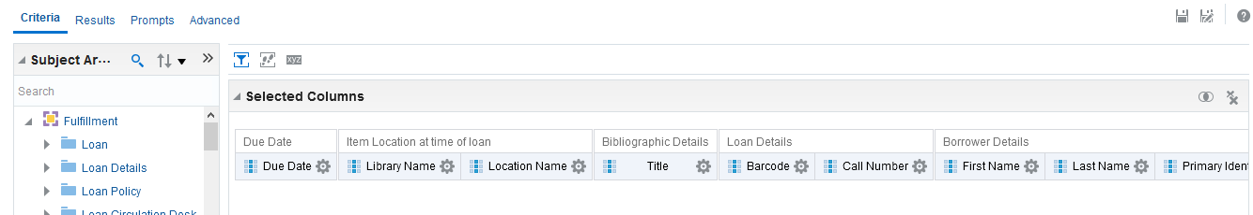

FOUR
We need to get only “Active” loans (not returned) so we will filter by loan status = active.

This is done by
- Add filter > More Columns
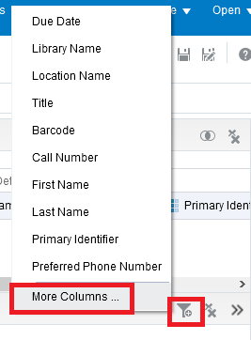
- Choose: ”Loan Details > Loan Status”
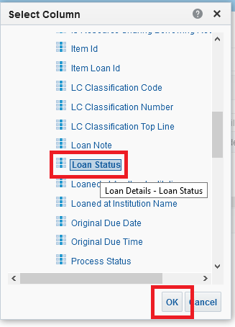
- Filter by “Loan Status = Active”
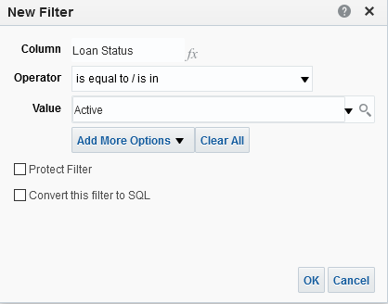

Now we will get everything with a due date 30 days or more in the past.
There are various ways to do this, we will show just one way.

This is done by
- Add filter > More Columns
- Choosing “Due Date > Due Date Filter” and “OK”
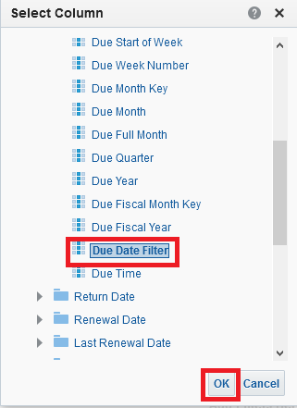
- Choose “Is equal to “Older than 30 days”
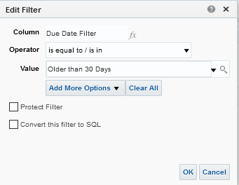

FIVE
Click the “Results” tab and see report

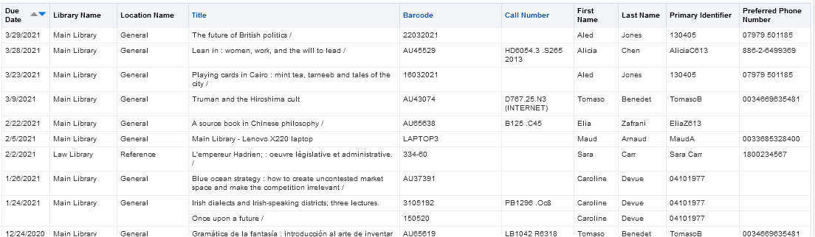

SIX
Save report
Click “Save As” on top right

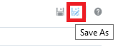

Choose location and save

